Group Members:

Class:
Tourism Video Project
Kyoto

For the Group Presentation, your group will make a 10-15 minute presentation (3-4 minutes/member) about a country and its contributions to science and technology.
There are SIX steps:

- Group Planning
- Plan Video Segments, Write Scripts
- How-to-make-a-video Demo, Writing
- Check Scripts, Speaking Practice
- On location (no formal class)
13 & 14 Watch Videos
Date: _______________________

For the Kyoto Tourism Video Project, your group (3 or 4 students) will make a 10-minute video to teach foreign tourists about Kyoto, Japanese culture, food, and language. Work with your group to plan your tourism videos. After each presentation, there will be 5 minutes for questions and answers from the teacher and/or the other class members.
WEEK

Guidelines:

- Videos should be at least 10 minutes long.
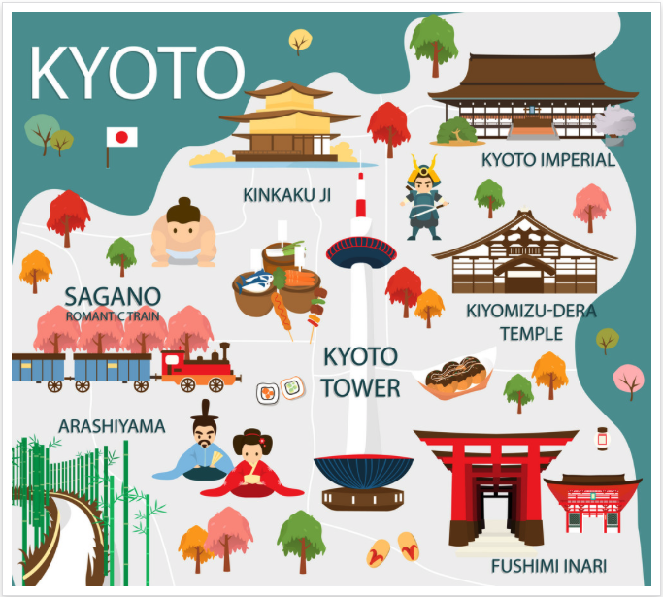
- All students must speak and appear on camera.
- Each student must speak for at least 2~3 minutes.
- Videos should be in English. If Japanese is used, it must be translated directly or with subtitles.
- Videos should consist of 3~6 segment topics: a sightseeing spot in Kyoto, Japanese culture, food, language, history, advice for tourists, interview with shop owner, interview with tourists, etc.

Segment Planning:

Topic | Director | Outline of Segment (Where? What happens?) | Time

Video Script Planning

- Introduction to Video and Members:

- Short overview of Kyoto:

- Transition to Segment #______:

- Segment #______:

- Transition to Segment #______:

- Segment #_______:

- Transition to Segment #______:

- Segment #______:

- Final Message about Kyoto:

(attach extra paper if needed)

